STOCK MARKET PREDICTION USING MULTI-SOURCE MULTIPLE INSTANCE LEARNING
Design and Implementation
Department of Computer Science and Engineering, [COLLEGE NAME]
Batch C4 (CSE-C) · Academic year [ACADEMIC YEAR]
Table 1: Project team
S.No. | Student name | Roll number
1 | Pottepaka Lingaswamy | 23K91A05J7
2 | Maduna Naveen Kumar | 23K91A05D7
3 | Meedigeri Keerthi | 24K95A0517
4 | Mareddy Sai Karthik | 23K91A05E8

Project guide: K Anusha
Chapter and section numbers quoted in the text (for example Chapter 8 or Section 6.2) refer to the full project report, 17.Final Document. Figures and tables in this document are numbered from 1.

1. DESIGN
This chapter describes how QuantPulse is built: the architecture and workflow, the data flow, the module, sequence and use-case design, the data design, the three core algorithms, the module and API design and the user interface. Every diagram was drawn from the code in backend/ and frontend/src/ and is reproduced with an explanation; the full set is also collected in the Block Diagrams document. Two facts about the design are stated at the outset because they shape everything below. QuantPulse has no database and no authentication: all state is files, and the website is open. And it has no multiple-instance-learning component: news enters the model as one averaged sentiment number per trading day, so the design follows the base paper [1] rather than the multiple-instance formulation that the project title and objectives describe. The offline study that addresses that formulation is a separate script, described in Chapter 6.

1.1 Design Goals and Architecture
Five goals shaped the design. First, reproduce the base paper's pipeline as a usable product: ARIMA, SARIMAX, Prophet, Random Forest and SVR baselines, an LSTM, a multi-head-attention LSTM, a sentiment channel from FinBERT-tone headlines and a simulated federated-averaging stage, all on ten technology and logistics tickers [1]. Second, fast screens: training takes minutes on a CPU, so it is run offline once and the web tier serves stored JSON, which is why most endpoints answer in about ten milliseconds (Chapter 7). Third, say where the data came from: every ticker carries a mode label (live, csv or synthetic), the sentiment source is shown on its own screen, and the Forecast screen warns when the stored forecast starts before the newest price. Fourth, run on a laptop without a GPU, which fixed the choice of CPU TensorFlow, PyTorch for FinBERT inference only, and small networks. Fifth, keep it replaceable: every hyper-parameter is in config.py, and the ticker universe is an environment variable.
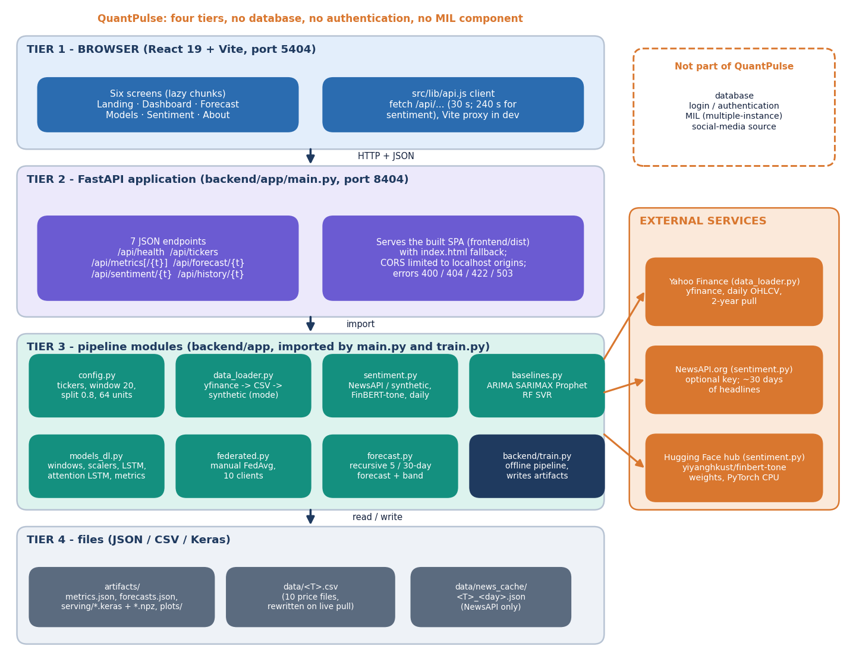
Figure 1: Four-tier architecture of QuantPulse: React website, FastAPI application with seven JSON endpoints, pipeline modules, and JSON / CSV / Keras files, with three external services.
The browser tier is a React 19 and Vite single-page website on port 5404 with six screens; its api.js client calls the backend under /api and Vite proxies the calls in development. The FastAPI application on port 8404 offers seven JSON endpoints (health, tickers, metrics, per-ticker metrics, forecast, sentiment and history) and also serves the built website with an index.html fallback. Underneath, the pipeline modules config, data_loader, sentiment, baselines, models_dl, federated and forecast are imported by main.py and by the offline training script train.py. State lives only in files: artifacts/ (metrics, forecasts, Keras models, plots), data/ (price CSVs) and data/news_cache/. Yahoo Finance, the optional NewsAPI service and the Hugging Face hub (FinBERT-tone weights) are outside the system. QuantPulse has no database, no authentication and no multiple-instance-learning component.
Ports are fixed by the batch: the API listens on 127.0.0.1:8404 and the website on 5404. Cross-origin calls from the localhost origins on ports 5173, 5404, 8000 and 8404 (and from 127.0.0.1 on 5173 and 5404) are allowed, so the Vite development server, the prebuilt site and the Docker image all work. The pipeline modules contain no web code, and main.py contains no model code: it never loads the saved Keras files, it only reads artifacts/metrics.json and forecasts.json. The Keras models and scalers are written by training so that a forecast could be regenerated, but nothing in the running application uses them.

1.2 High-Level Workflow
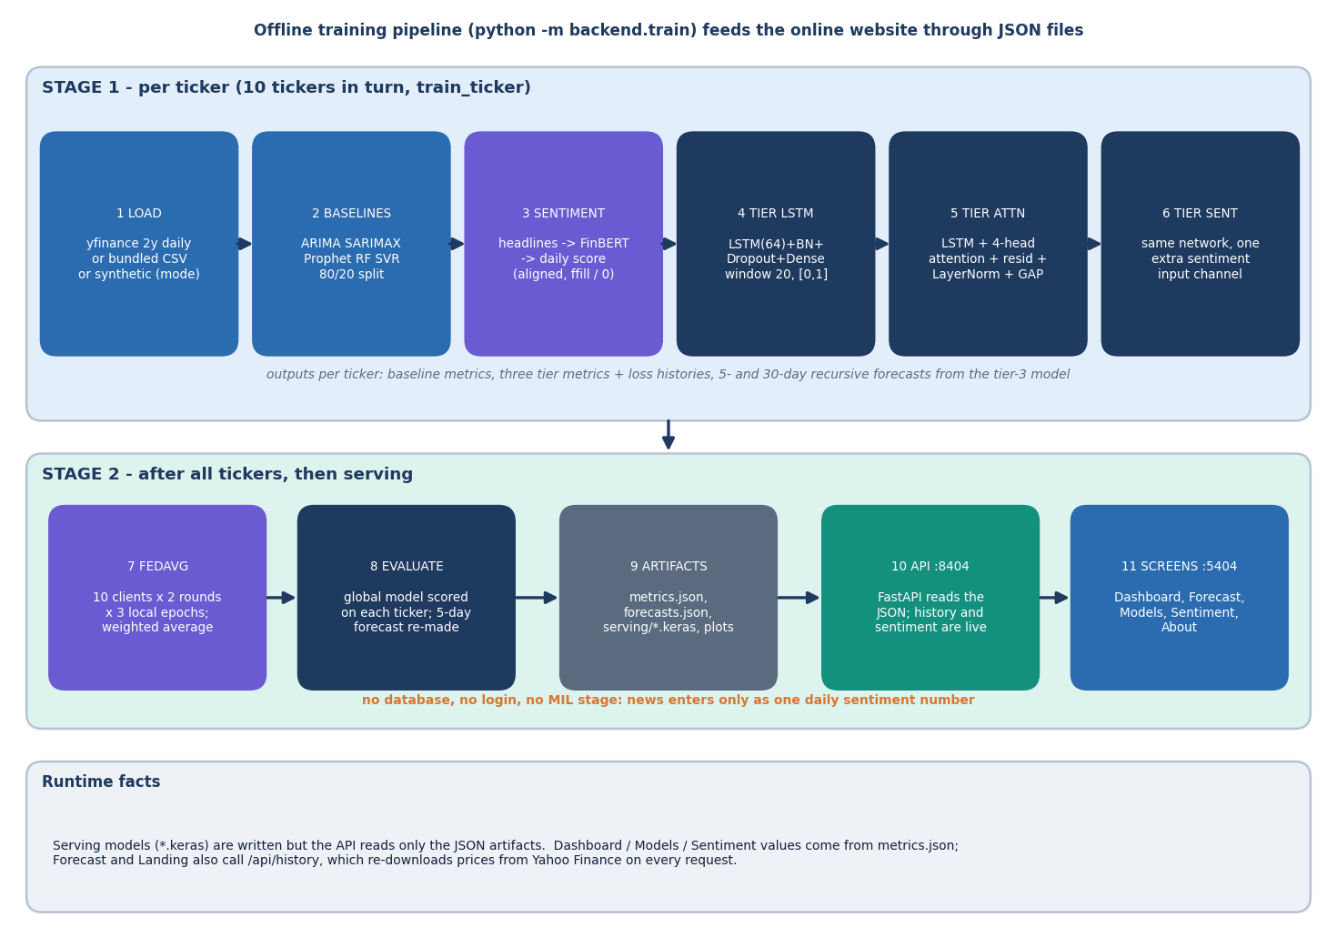
Figure 2: Offline training pipeline (python -m backend.train) in two stages, then serving of the JSON artefacts to the website.
Stage 1 runs once per ticker for the ten tickers in turn. The prices are loaded from Yahoo Finance, the bundled CSV or a labelled synthetic series; five classical baselines are scored on an 80/20 chronological split; daily sentiment is built from headlines scored by FinBERT-tone; and three deep tiers (LSTM, LSTM with four-head attention, and the same network with a sentiment channel) are trained on 20-day windows scaled to [0, 1]. The recursive 5- and 30-day forecasts come from the third tier. Stage 2 starts after all tickers are done: the third-tier network is averaged across the ten tickers by FedAvg, scored on each ticker, and its 5-day forecast replaces the local one; the results are written to metrics.json, forecasts.json, the serving models and the plots. At run time the API reads only the JSON files, except that the history and sentiment endpoints go back to Yahoo Finance and FinBERT. News enters only as one daily sentiment number, so the workflow has no database, no login and no multiple-instance stage.
The workflow has two time scales. The training pipeline is a command-line program, python -m backend.train, which takes five to ten minutes on a CPU and writes everything the website shows. The serving path is a few lines of FastAPI. The only operations that leave the machine at run time are the history call, which re-downloads prices from Yahoo Finance, and the first sentiment call, which loads the FinBERT-tone model from the Hugging Face cache.

1.3 Data Flow Diagrams

1.3.1 Level 0: context
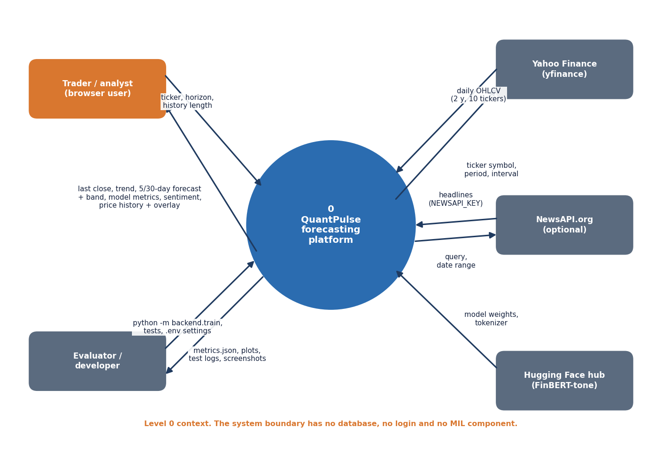
Figure 3: Context diagram (DFD level 0): one process, the trader or analyst, the evaluator or developer, and three external data sources.
At level 0 the product is one process with three kinds of neighbour: the trader or analyst (browser), the evaluator or developer (scripts and tests) and three external services (Yahoo Finance, NewsAPI and the Hugging Face hub for FinBERT-tone).

1.3.2 Level 1: seven processes
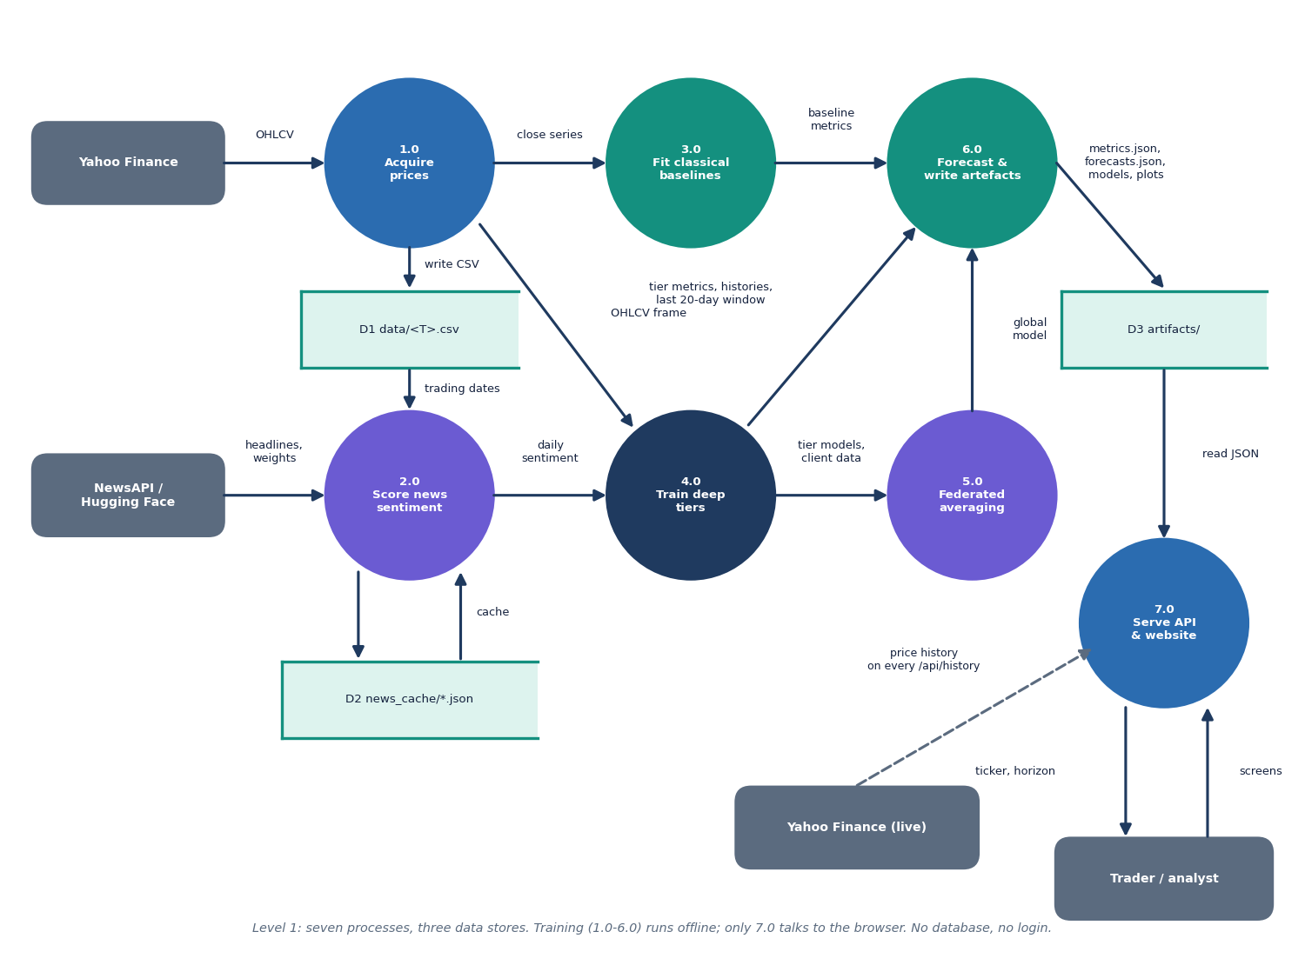
Figure 4: DFD level 1: seven processes (acquire prices, score sentiment, fit baselines, train deep tiers, federated averaging, forecast and write artefacts, serve) and three data stores.
Process 1.0 downloads prices and writes them to the CSV files (D1); the close series goes to the baselines (3.0) and the OHLCV frame goes to the deep-tier training (4.0). Process 2.0 reads the trading dates, fetches or generates headlines (cached in D2), scores them with FinBERT-tone and hands a daily sentiment series to 4.0. Process 4.0 passes its trained models and client data to the federated averaging (5.0) and its metrics, loss histories and last 20-day windows to process 6.0. Process 6.0 combines baseline metrics, tier metrics and the global model, makes the recursive forecasts and writes the artefacts (D3). Process 7.0, the FastAPI application and website, reads D3 for the trader and goes to Yahoo Finance on every history request. Processes 1.0 to 6.0 run offline; only 7.0 faces the browser.
Processes 1.0 to 6.0 are one offline script (acquire prices, score sentiment, fit baselines, train deep tiers, average federatedly, forecast and write artefacts); process 7.0 is the FastAPI application. The three stores are files: D1 data/<T>.csv, D2 data/news_cache/ (only with a NewsAPI key) and D3 artifacts/.

1.3.3 Level 2: training one deep tier
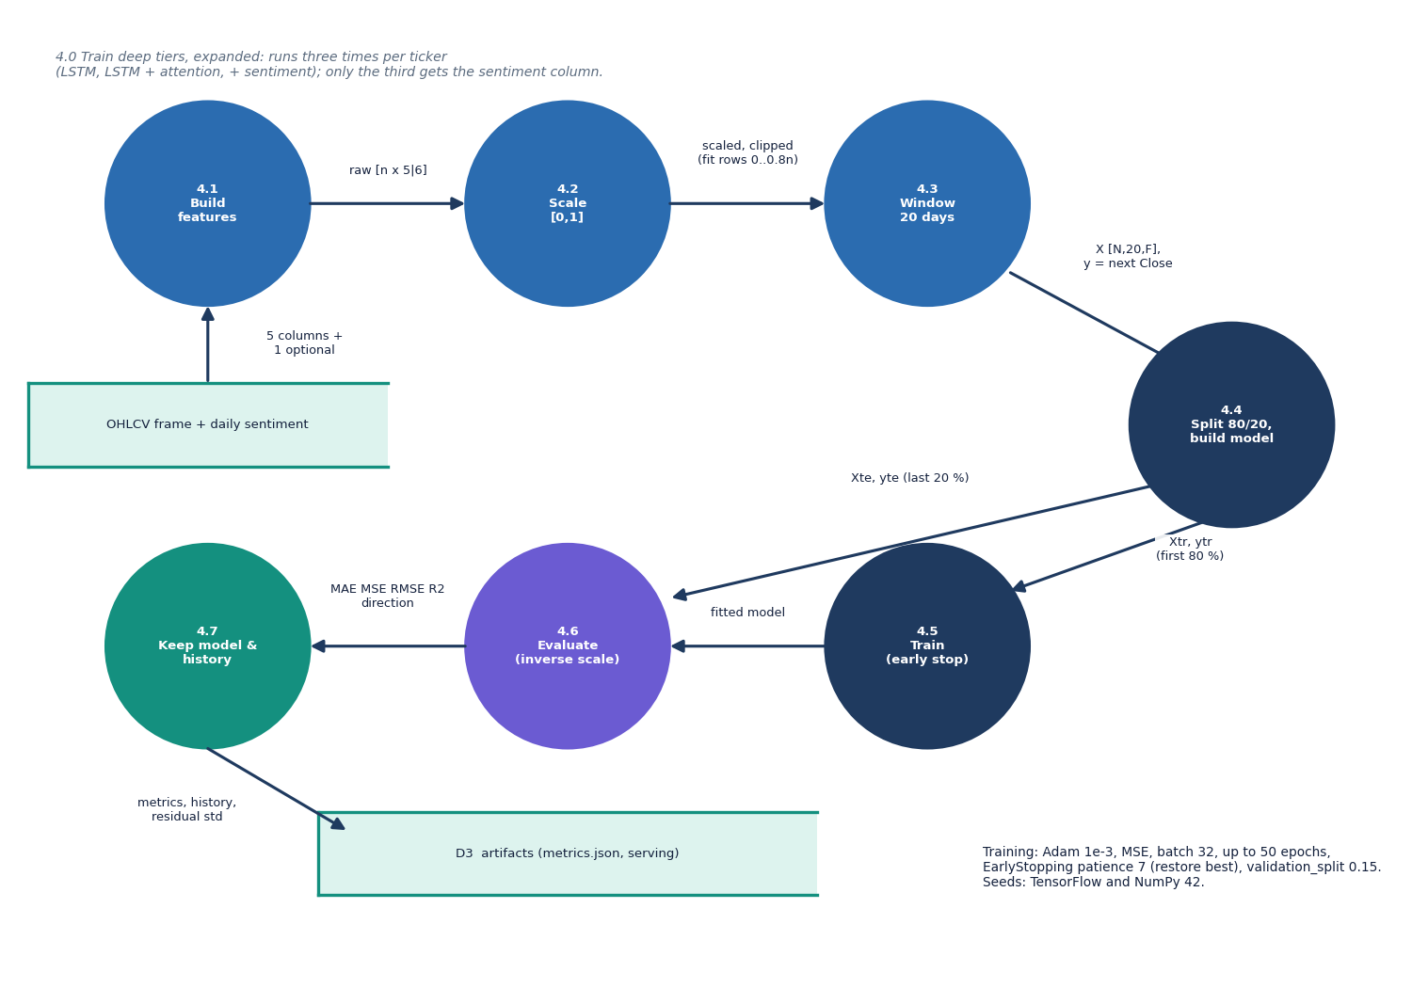
Figure 5: DFD level 2: process 4.0, training of one deep tier, expanded into seven sub-processes.
Level 2 expands the training of one deep tier into seven steps. Step 4.2 carries the design's most consequential choice: the scalers are fitted on the first 80 % of the rows but applied to every row and clipped to [0, 1], so a test price above the training maximum is flattened to 1.0 (Chapter 8 shows this matters).

1.4 Module, Sequence and Use-Case Design

1.4.1 Module (class) diagram
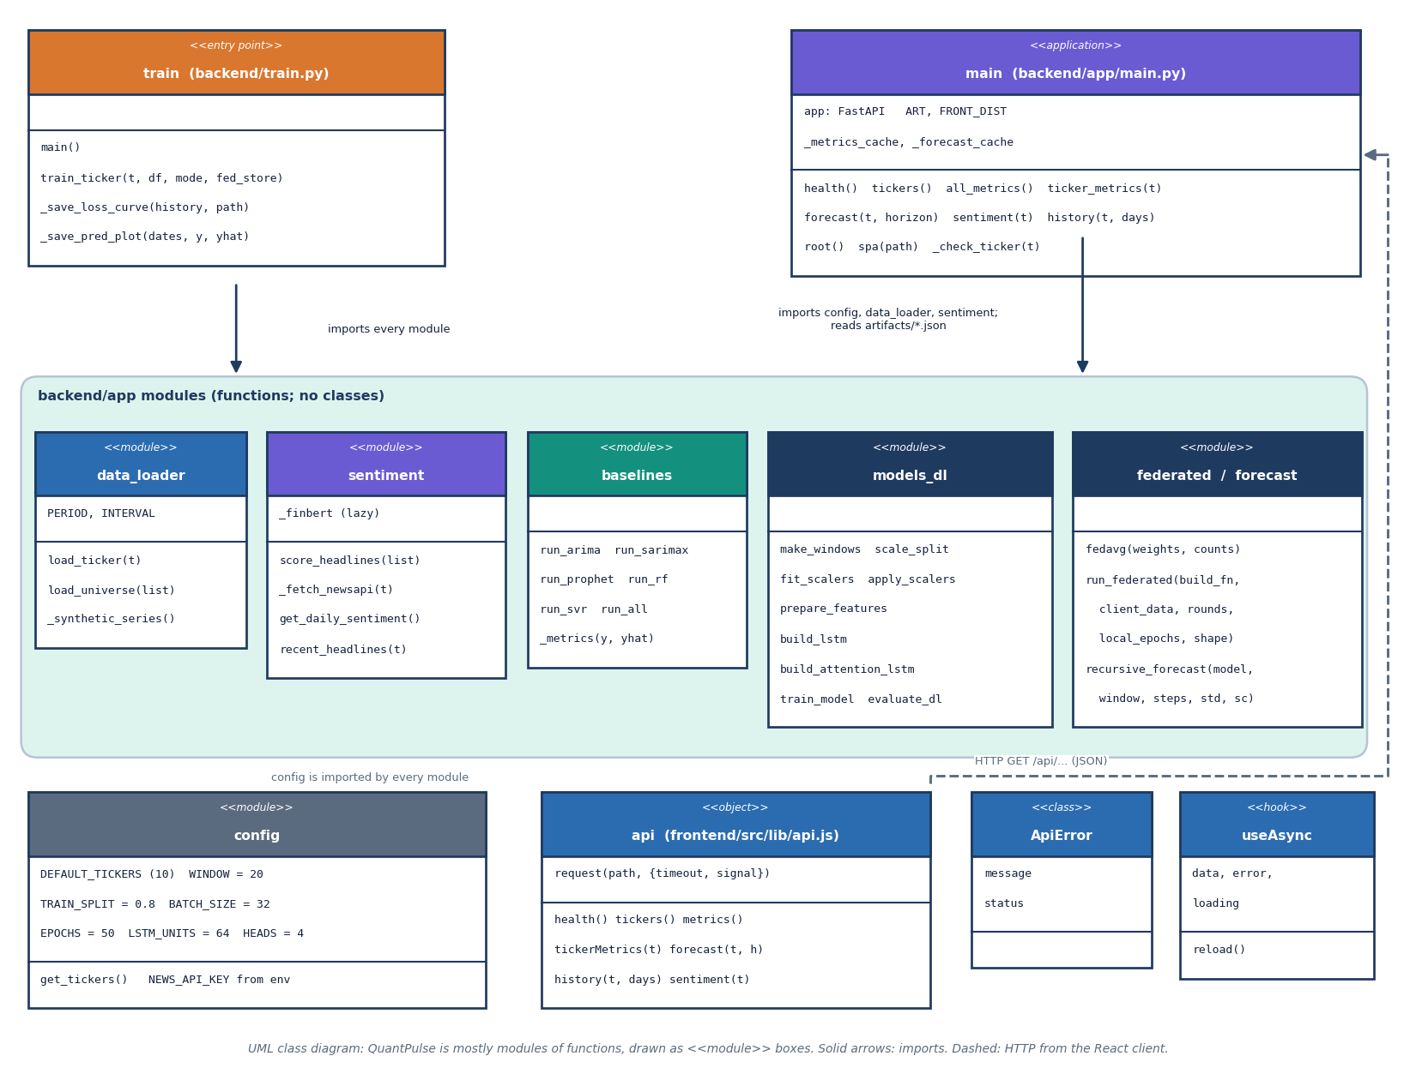
Figure 6: UML class diagram: the backend is a set of function modules, so modules are drawn as boxes with their functions, together with the React API client, ApiError and the useAsync hook.
QuantPulse is written mostly as modules of functions, so the diagram draws each module as a box listing its constants and functions. The entry script train.py imports every module under backend/app; main.py, the FastAPI application, imports config, data_loader and sentiment and reads the artefact JSON through a cached loader. config holds the ticker list and hyper-parameters, data_loader the three-step price source, sentiment the NewsAPI, FinBERT and synthetic-headline logic, baselines the five classical models, models_dl the windowing, scaling, the two Keras architectures, training and evaluation, federated the manual FedAvg loop and forecast the recursive forecast with its confidence band. On the browser side the api object wraps fetch with a timeout and raises ApiError; useAsync is the hook the screens use to call it. The only genuine classes are ApiError and the FastAPI application object.
The backend is deliberately a set of function modules, each small and testable on its own (the tests in tests/ call the functions directly); the only true classes are the front end's ApiError and the FastAPI application object.
Table 2: Backend modules and their roles.
Module | File | Role | Main functions
Configuration | backend/app/config.py | Tickers, window, split, batch, epochs, units, heads, horizons, paths, NewsAPI key | get_tickers
Price source | backend/app/data_loader.py | Live Yahoo download, bundled CSV, labelled synthetic series | load_ticker, load_universe, _synthetic_series
Sentiment | backend/app/sentiment.py | NewsAPI fetch and cache, FinBERT-tone or lexicon scoring, synthetic headlines, daily alignment | get_daily_sentiment, score_headlines, recent_headlines
Baselines | backend/app/baselines.py | ARIMA, SARIMAX, Prophet, Random Forest, SVR with one metric helper | run_all, _metrics
Deep models | backend/app/models_dl.py | Windows, scalers, two Keras architectures, training, evaluation | make_windows, build_lstm, build_attention_lstm, evaluate_dl
Federated | backend/app/federated.py | Manual FedAvg over per-ticker clients | fedavg, run_federated
Forecast | backend/app/forecast.py | Recursive multi-step forecast with confidence band | recursive_forecast
API | backend/app/main.py | Seven JSON routes, static site, validation | _check_ticker, forecast, history
Training script | backend/train.py | Runs the whole pipeline and writes artefacts and plots | train_ticker, main

1.4.2 Sequence diagram
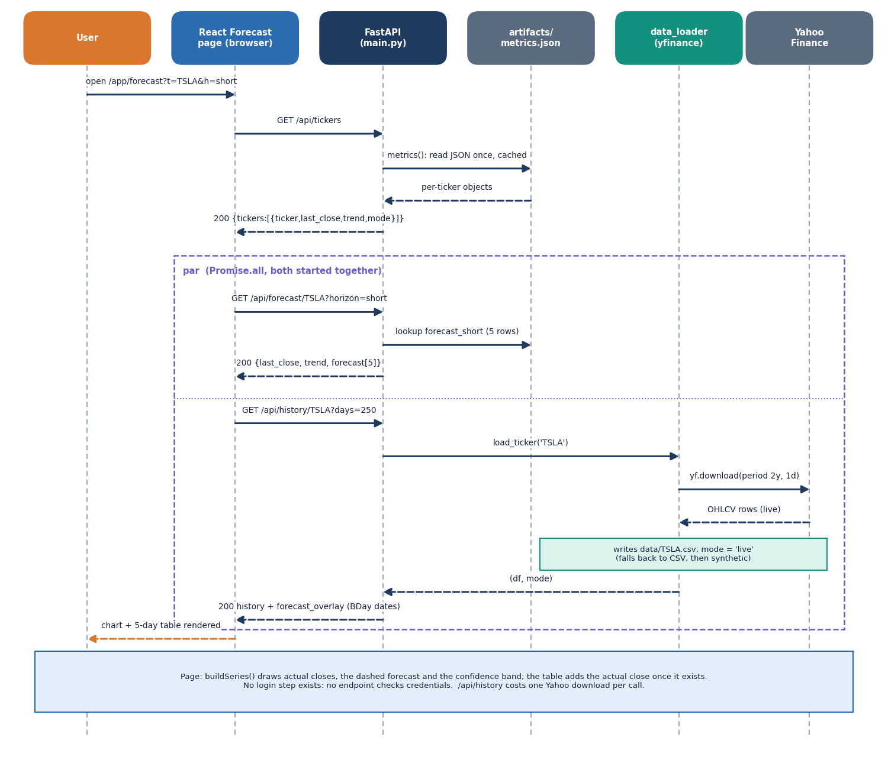
Figure 7: Sequence diagram: the user opens the Forecast screen; the page calls /api/tickers, then /api/forecast and /api/history in parallel; history goes live to Yahoo Finance.
Opening /app/forecast makes the React page call GET /api/tickers; main.py loads artifacts/metrics.json once, caches it and returns each ticker's last close, trend and data mode. The page then starts two requests together. GET /api/forecast/TSLA?horizon=short looks up the stored five forecast rows. GET /api/history/TSLA?days=250 calls load_ticker, which downloads two years of daily prices from Yahoo Finance, rewrites data/TSLA.csv and returns the latest 250 rows together with the stored forecast placed on the next business days. The page draws the actual closes, the dashed forecast and the confidence band, and the table shows the actual close once it exists. No request carries credentials, and the history call costs one Yahoo Finance download every time.
Opening the Forecast screen triggers /api/tickers, then /api/forecast and /api/history together; the history call goes live to Yahoo Finance and rewrites the price CSV, so it is the slowest of the three.

1.4.3 Use-case diagram
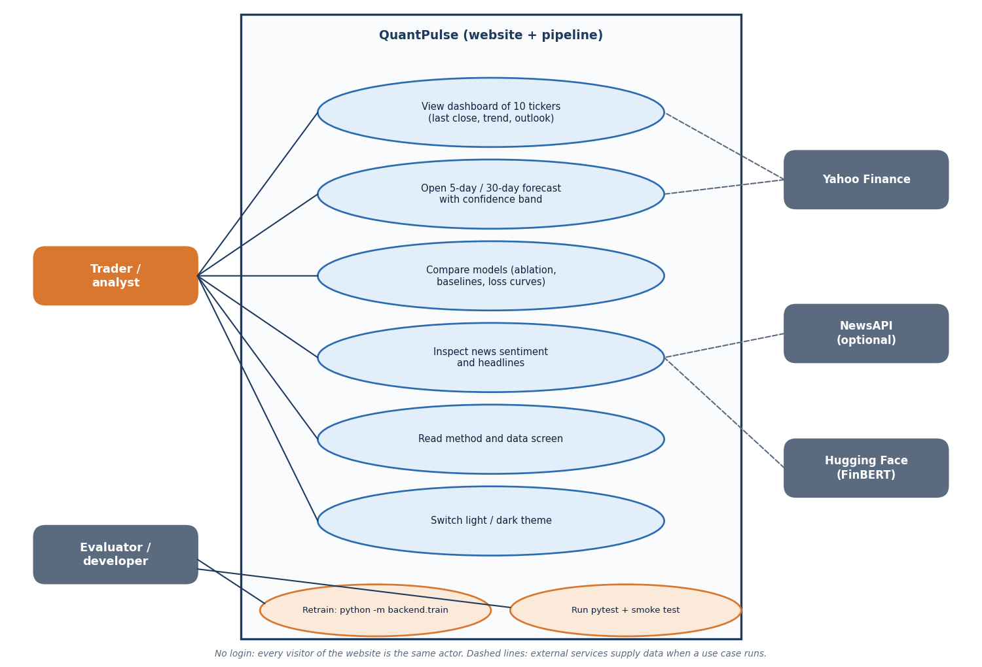
Figure 8: Use-case diagram with the trader or analyst, the evaluator or developer, and three external services.
There is one human role, the trader or analyst, who needs no login, and one technical role, the evaluator or developer; no administrator exists because there is no authentication.

1.5 Data Design
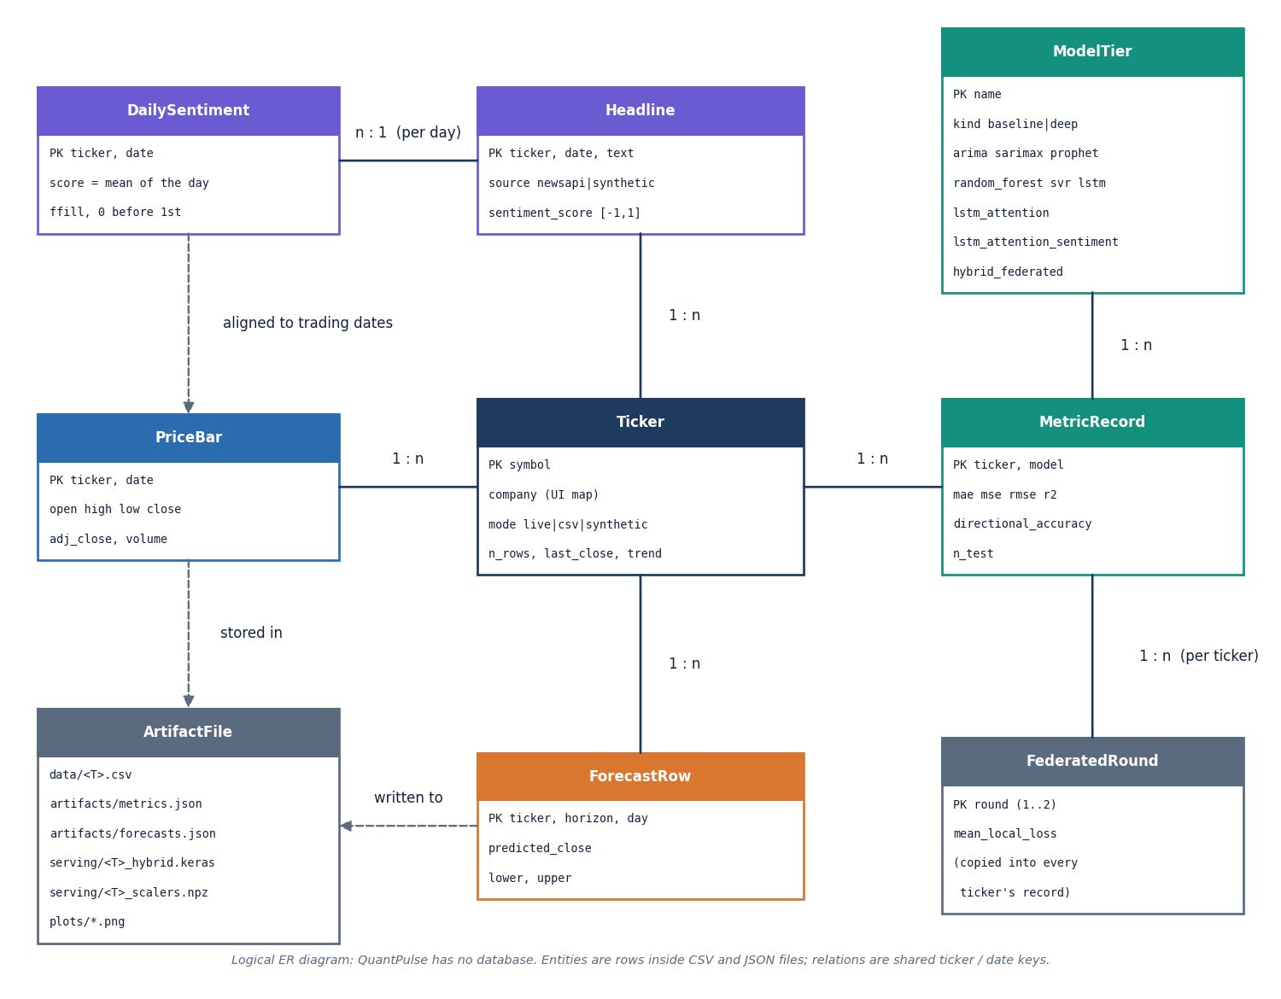
Figure 9: Logical entity-relationship diagram: QuantPulse has no database, so the entities are rows inside CSV and JSON files.
There is no database, so the entities are rows inside CSV and JSON files and the diagram is logical. The shape of artifacts/metrics.json is the de facto schema of the product; the table lists the parts of one ticker's record.
Table 3: Contents of one ticker's record in artifacts/metrics.json.
Field | Content | Written by
mode, n_rows | Price source (live, csv, synthetic) and number of daily rows used (501 for every ticker in the shipped run) | train_ticker
baselines | ARIMA, SARIMAX, Prophet, Random Forest, SVR: MAE, MSE, RMSE, R2, directional accuracy, n_test (101) | baselines.run_all
sentiment | Source (newsapi or synthetic-fallback), scorer (finbert, lexicon), headline count (166 to 191), note | get_daily_sentiment
deep | Four tiers with the same metric set and n_test = 97 | train_ticker, main
histories | Training and validation loss per epoch for three local tiers | train_model
forecast_short, forecast_long | 5 and 30 rows: day, predicted close, lower, upper | recursive_forecast
last_close, trend | Last training close and up/down flag (day-5 forecast against last close) | main
headlines | Eight headlines with their scores for the sentiment screen | recent_headlines
federated_rounds | Mean local loss for round 1 and 2 (same for every ticker) | run_federated

Price files are CSV with a date index and the columns Open, High, Low, Close, Adj Close and Volume (a synthetic file starts with # synthetic: true); the Keras files and scalers in artifacts/serving/ are saved per ticker. The API loads each JSON file once and keeps it in memory until restart.

1.6 Core Algorithm Design
Three algorithms carry the product and each has a flowchart; they are derived formally in Chapter 6.

1.6.1 Recursive forecast
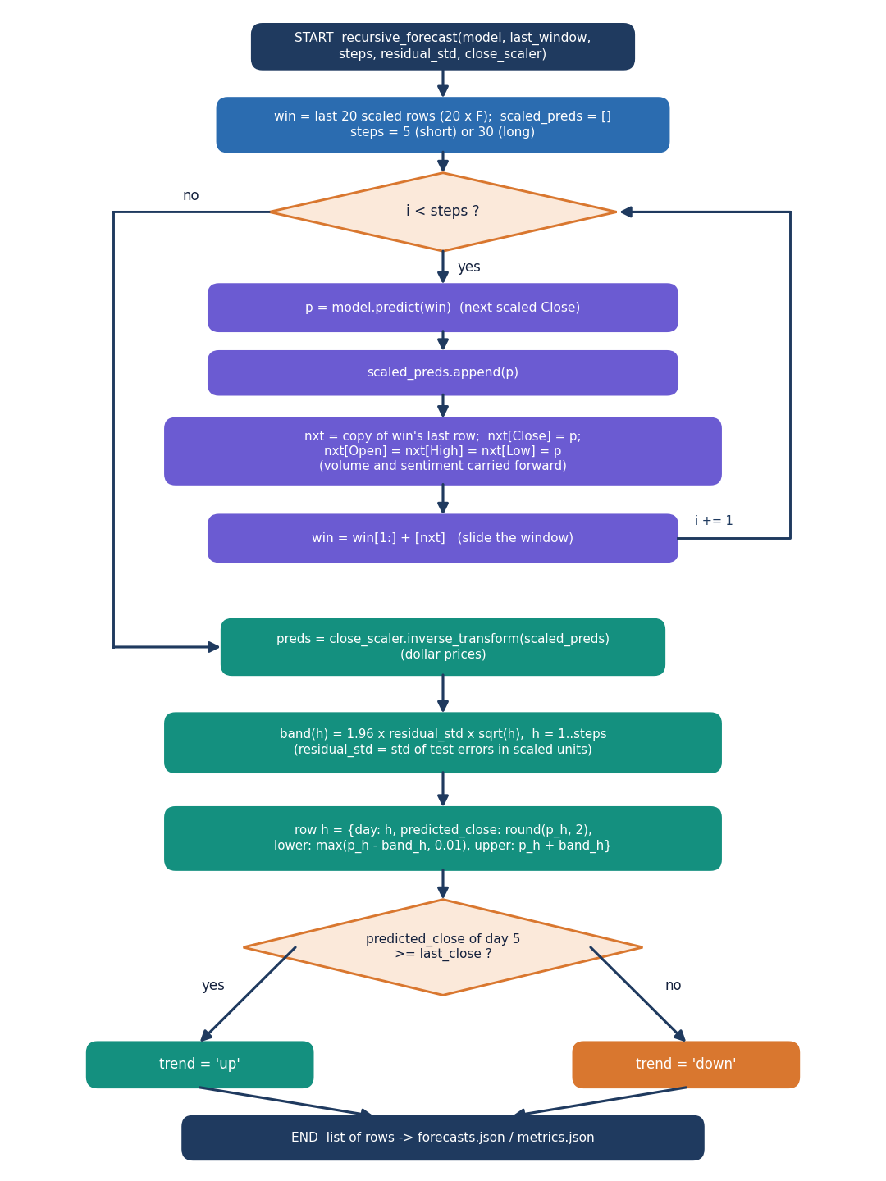
Figure 10: Flowchart of recursive_forecast: predict, roll the window, repeat, inverse-scale, add the 1.96 x residual std x sqrt(h) band and set the trend.
Each step feeds the prediction back as the next Close (and Open, High, Low) with volume and sentiment held constant, so after day one the forecast is driven by the model's own outputs; the band widens with the square root of the horizon.

1.6.2 Sentiment path
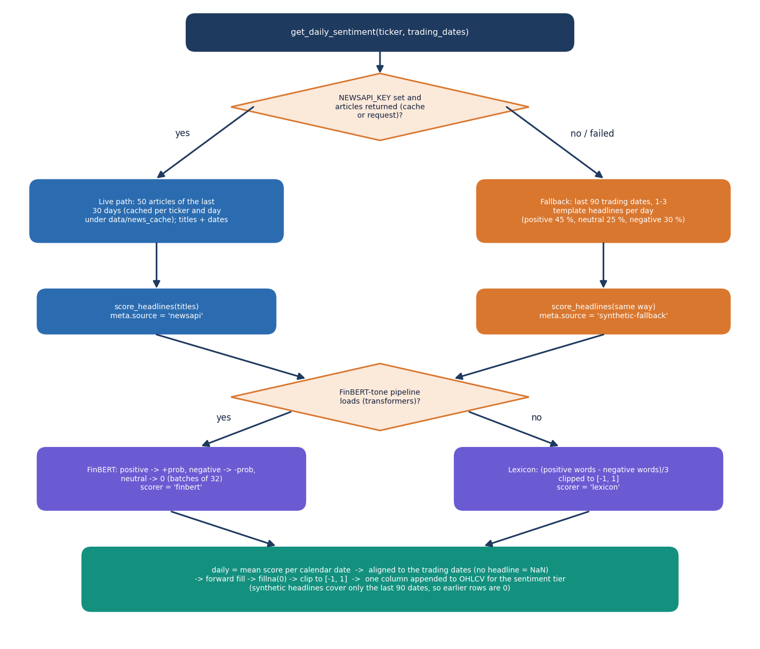
Figure 11: Flowchart of get_daily_sentiment: live NewsAPI headlines or the labelled synthetic fallback, FinBERT-tone or lexicon scoring, and alignment to the trading dates.
No key was configured in the shipped run, so every ticker used the synthetic path: 166 to 191 headlines per ticker from eleven fixed templates, which say nothing about real news. The screen labels this; the base paper's own NewsAPI limit of one month [1] is why live responses are cached per day.

1.6.3 Network architecture
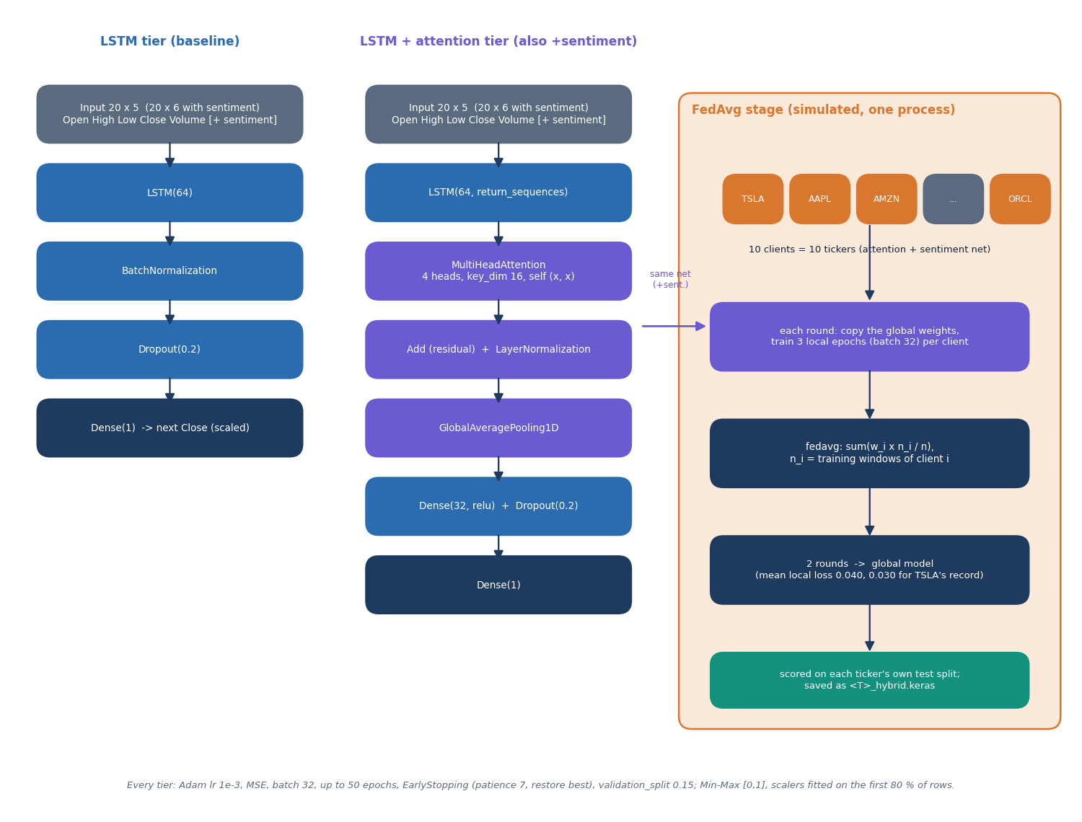
Figure 12: Architecture of the two network families (LSTM, and LSTM with four-head attention) and of the simulated FedAvg stage.

1.7 Module Design of the Website
The website is a single-page React 19 application (Vite 8, React Router 7, Recharts 3, Framer Motion) on the "Soft Pastel Calm" kit, with six lazily loaded screens; each asks the API through one hook and renders loading, error, empty and data states.
Table 4: Website modules.
Module | File(s) | Role
Router and shell | App.jsx, components/ui/Layout.jsx | Routes / (landing) and /app/*; sidebar, top bar with the API status pill, theme toggle
Landing | pages/Landing.jsx | Hero with a live price chart of the first ticker, feature sections, call to action
Dashboard | pages/Dashboard.jsx | Four KPI cards, ten ticker cards with sparklines, sortable universe table
Forecast | pages/Forecast.jsx | Ticker tabs, horizon and history selectors, KPIs, chart with band, forecast table with actual closes, stale-model banner
Model comparison | pages/Models.jsx | KPIs, ablation chart, all-model MAE chart, deep and baseline tables, loss curves, federated rounds
News sentiment | pages/Sentiment.jsx | Source, headline count, 30-day mean, daily chart, searchable headline list with tone filter
Method and data | pages/About.jsx | Pipeline timeline, installation facts from the API, data table per ticker
API client | lib/api.js | fetch wrapper with a 30 s timeout (240 s for sentiment), abort support and ApiError
Hooks and helpers | lib/hooks.js, market.js, format.js, palette.js, theme.jsx | useAsync, useRefresh, model labels, buildSeries (aligns forecast and history), number and date formats, light and dark tokens
UI kit and charts | components/ui/*, components/charts/index.jsx | Buttons, cards, tables, tabs, toasts, skeletons; area, bar, line, grouped-bar and forecast charts with accessible labels

The most delicate front-end logic is buildSeries: the stored forecast starts from the last training close, which can be older than the live history, so the function anchors the forecast on the history row with that close, lays it on the following business days and adds the actual close and percentage miss for every forecast day that has already happened. If no row matches it shows the stale warning.

1.8 API Design
The API is read-only JSON: seven routes under /api, with the same process serving the built website. Request and response shapes are in Chapter 6.
Table 5: API routes.
Route | Purpose | Errors
GET /api/health | Readiness, tickers, whether artefacts exist, news source | none
GET /api/tickers | Universe with last close, trend and data mode | none
GET /api/metrics | All records | 503 when not trained
GET /api/metrics/{ticker} | One record | 400 invalid symbol, 404 unknown
GET /api/forecast/{ticker}?horizon= | 5 or 30 forecast rows | 400, 404, 422 bad horizon
GET /api/sentiment/{ticker} | Meta, 30 daily scores, headlines | 400
GET /api/history/{ticker}?days= | OHLCV rows and forecast overlay | 400, 422 days outside 20 to 500

1.9 User Interface Design
Four rules guide the interface. Calm and legible: warm off-white surfaces, pastel tones by category (lavender deep models, blue baselines, mint positive, rose negative) and tabular figures. Honest states: skeletons, error states with retry, empty states and an "API online, models ready" pill. Accessible: charts carry an aria-label, tabs and segmented controls use tab and radio roles, and motion respects reduced-motion. Two themes share the same tokens; the choice is stored in the browser.
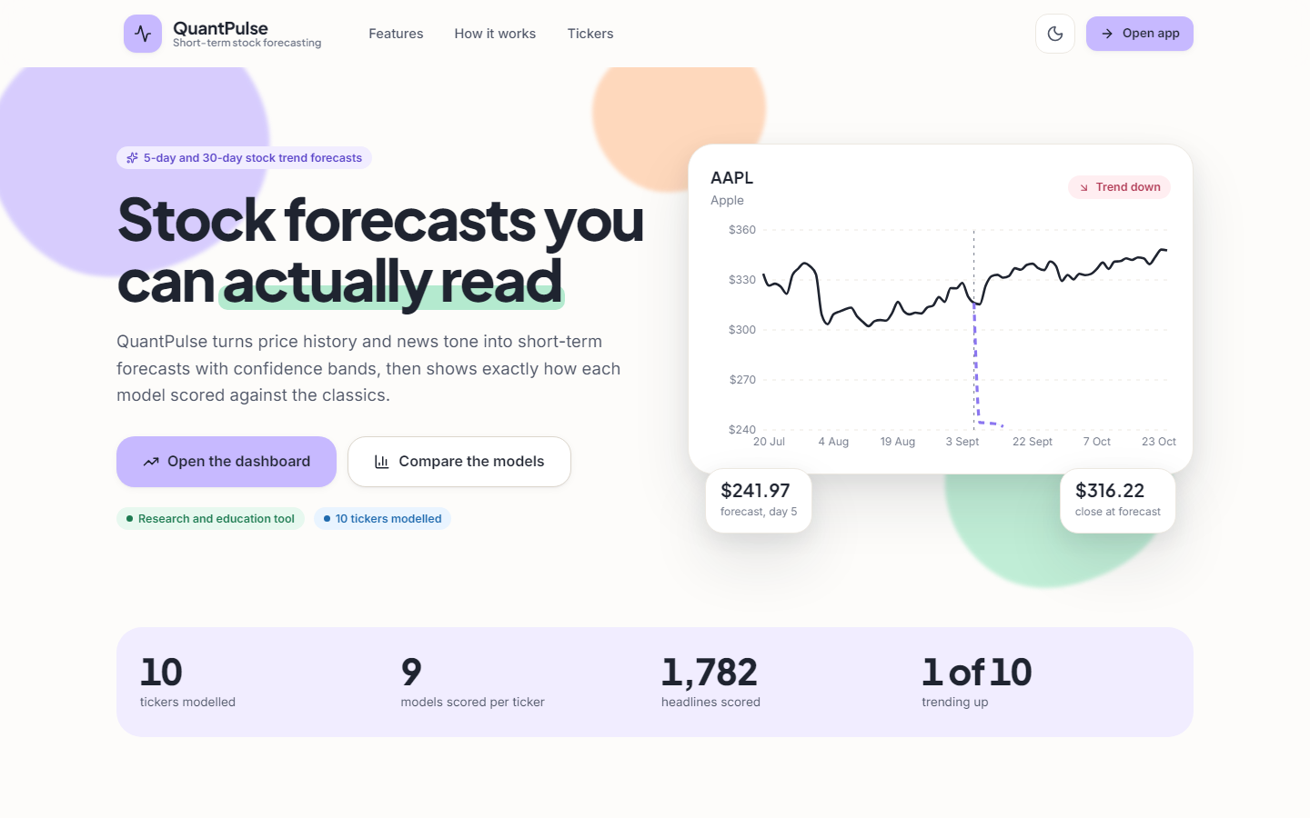  Figure 13: Landing page in the light theme. | 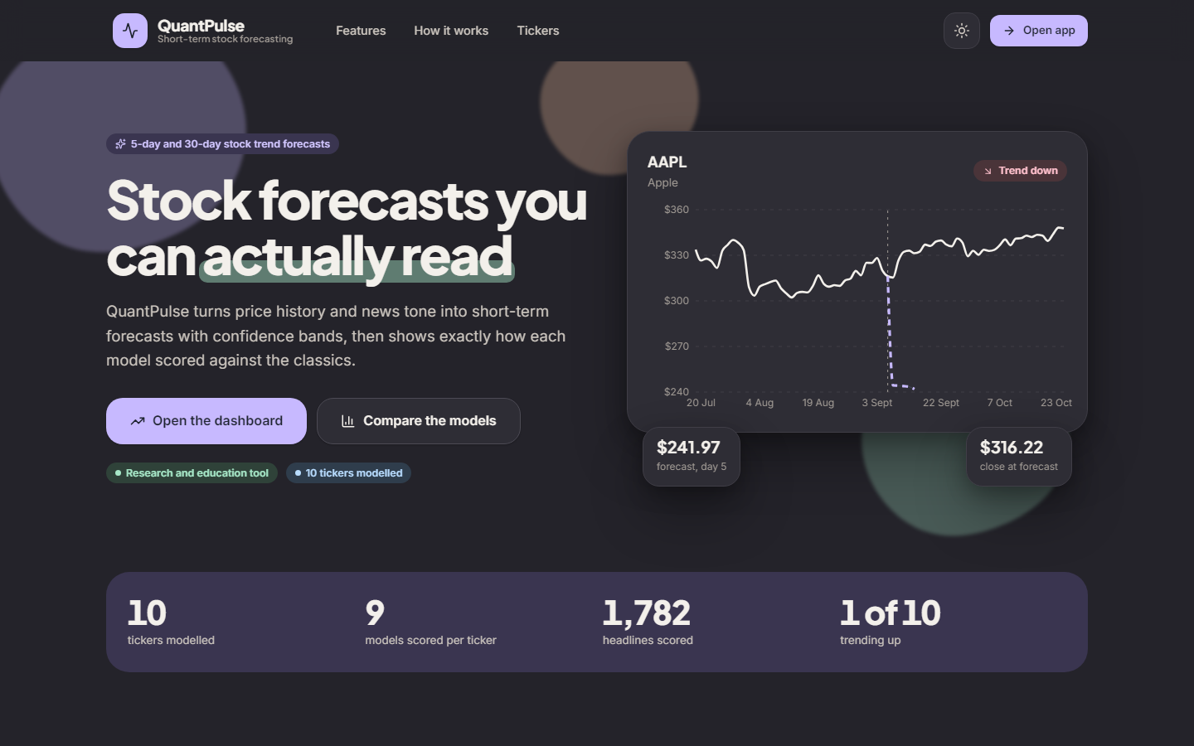  Figure 14: Landing page in the dark theme.

Table 6: Screens and their data sources.
Screen | Route | API calls | What the user can do
Landing | / | tickers, metrics, history (first ticker, 250 days) | Read the pitch, open the app
Dashboard | /app | tickers, metrics | Scan ten tickers, sort the table, open a forecast
Forecast | /app/forecast | tickers, then forecast and history together | Pick ticker, 5- or 30-day horizon, 60 to 250 days of history; read the table with actual closes
Model comparison | /app/models | tickers, metrics/{t} | Compare nine models, see loss curves and federated rounds
News sentiment | /app/sentiment | tickers, sentiment/{t} | See source and daily mood, search and filter headlines
Method and data | /app/about | health, metrics | Read the pipeline and per-ticker data modes

1.10 Design Trade-offs and Known Weaknesses
• Precomputed artefacts keep the site fast but go stale: the shipped ones end at 2026-09-08; the Forecast screen says so, only retraining fixes it.
• The history route downloads on every call: the chart stays current at about 140 ms per call (Chapter 7) and depends on Yahoo Finance being reachable.
• Function modules share a few module-level caches (the FinBERT pipeline, two JSON caches) that would need a lock under heavy concurrency.
• No authentication and no database: the API is read-only with no personal data and files suffice for ten tickers; watch-lists or forecast history would need both.
• Simulated federated learning: the clients share one process and one scaling convention; a real deployment would need transport, secure aggregation and per-client scaling.

2. IMPLEMENTATION

2.1 Application Architecture
The application is one Python process plus a static website. main.py creates the FastAPI object with a CORS middleware, defines seven routes and, when frontend/dist exists, serves /assets and a catch-all that returns index.html for client-side routes. Nothing is loaded at start-up: the first request reads artifacts/metrics.json (and later forecasts.json) into a module-level cache. In development Vite serves the website on port 5404 and proxies /api to 127.0.0.1:8404; otherwise the API serves the built website itself.
Figure 15: Sequence diagram: the user opens the Forecast screen; the page calls /api/tickers, then /api/forecast and /api/history in parallel; history goes live to Yahoo Finance.
The /api/history route calls load_ticker, which tries a live download, then the CSV, then the synthetic generator, so a chart can always be drawn; the route then places the stored forecast on the next business days after the last bar. The /api/sentiment route calls get_daily_sentiment for the ticker's dates, which loads FinBERT-tone on first use into a module-level singleton and is the slowest call of the system.
The training script is the other half of the application. train_ticker runs the baselines, builds the sentiment series and calls an inner run_tier three times (LSTM, attention, attention with sentiment); each call builds the features, fits the scalers, makes the windows, trains with early stopping and scores the test windows. The recursive forecasts come from the third tier. After the ten tickers, main runs two federated rounds over the third tier, scores the global model on every ticker, replaces each ticker's 5-day forecast and trend with the global model's, saves the Keras files and scalers, draws four plots for TSLA and writes metrics.json and forecasts.json; the stored 30-day forecast therefore still comes from the local attention and sentiment model.

2.2 API Design
Table 7: Routes, parameters and responses.
Route | Parameters | Success response | Errors
GET /api/health | none | {status, product, tickers[], trained, news_source} | none
GET /api/tickers | none | {tickers:[{ticker, last_close, trend, mode}]} | none
GET /api/metrics | none | {<TICKER>: record} for ten tickers (about 76 KB) | 503 not trained
GET /api/metrics/{ticker} | symbol of 1 to 6 letters | {ticker, ...record} | 400 invalid, 404 unknown
GET /api/forecast/{ticker} | horizon = short or long (default short) | {ticker, horizon, last_close, trend, forecast:[{day, predicted_close, lower, upper}]} | 400, 404, 422
GET /api/sentiment/{ticker} | symbol | {ticker, meta, daily:[{date, score}] (30), headlines:[{headline, sentiment_score}]} | 400
GET /api/history/{ticker} | days 20 to 500 (default 120) | {ticker, mode, history:[{date, open, high, low, close, volume}], forecast_overlay:[{date, predicted_close, lower, upper}]} | 400, 422

GET /api/forecast/TSLA?horizon=short
{"ticker": "TSLA", "horizon": "short", "last_close": 368.16, "trend": "down", "forecast": [{"day": 1, "predicted_close": 316.57, "lower": 316.28, "upper": 316.86}, {"day": 2, "predicted_close": 314.58, "lower": 314.17, "upper": 314.99}, "..."]}

GET /api/forecast/T5LA -> 400 {"detail": "Invalid ticker 'T5LA'. Use 1-6 letters, e.g. TSLA."}
GET /api/forecast/ZZZZ -> 404 {"detail": "No forecast for 'ZZZZ'. Train the pipeline first."}
GET /api/forecast/TSLA?horizon=weekly -> 422 (query validation)

The record returned for a ticker has the fields listed in Section 5.5. Every route is a plain GET with no body; the API is read-only and idempotent, which makes it safe to cache and to test. Interactive documentation is available from FastAPI at /docs.

2.3 Front-End Implementation
Each page calls useAsync with a function that receives an abort signal (so changing the ticker cancels the request) and renders a skeleton while loading, an ErrorState with a retry button on failure and an EmptyState when there are no rows. The API client sets a 30-second timeout (240 seconds for sentiment, because the first call loads FinBERT) and turns every failure into an ApiError. Charts are Recharts components with an aria-label, and animation is off when the user prefers reduced motion. buildSeries in lib/market.js anchors the stored forecast on the history row with the training last close and annotates every forecast day that already has an actual close.

2.4 Security and Error Handling
• Input validation. A ticker must match ^[A-Za-z]{1,6}$ before any file or network access; horizon must be short or long and days between 20 and 500, enforced by FastAPI query validation (HTTP 422).
• Errors. Invalid symbol 400 with a message, unknown ticker 404 listing the configured tickers, missing artefacts 503 with the command to run; unknown /api/... paths return 404 instead of the single-page fallback.
• Network failure. A failed Yahoo download falls back to the CSV and then to a labelled synthetic series; a missing FinBERT model to a word-list scorer (scorer: lexicon); a failed NewsAPI call to the synthetic headlines.
• No authentication, no personal data. The API is read-only and binds to 127.0.0.1; CORS is limited to localhost origins. A public deployment would need rate limiting and a reverse proxy. The optional NEWSAPI_KEY is read from the environment or .env (ignored by Git) and never sent to the browser.
• Honesty features. The mode of every price series, the news source and the stale-forecast banner are displayed; the README states that forecasts are not financial advice.

2.5 Installation and Execution
The one-click path is run.bat. In six steps it finds Python 3.11, creates or repairs .venv, installs backend/requirements.txt once, trains the models only if artifacts/metrics.json is missing (five to ten minutes on a CPU), installs the website packages, and opens the API on port 8404, the website on port 5404 and the browser; ports come from .env.
1. Install Python 3.11 and Node.js 20 or newer; optionally put a NEWSAPI_KEY in .env.
2. Run run.bat, or manually: py -3.11 -m venv .venv, activate it, python -m pip install -r backend\requirements.txt, python -m backend.train, python -m uvicorn backend.app.main:app --host 127.0.0.1 --port 8404.
3. For live reload: cd frontend, npm install, npm run dev (port 5404, proxying /api).
4. Without Node.js the API serves the prebuilt frontend/dist at http://localhost:8404.
5. With Docker: docker compose up --build; the image serves the prebuilt site and API on port 8000 (the Docker route was not exercised in this work).
6. Check the stack with python scripts/smoke_test.py (26 checks) and the unit tests with pytest tests (56 tests).
Retraining with python -m backend.train rewrites artifacts/ and is the only way to move the forecast origin to the latest price. The documentation experiments are separate scripts (run_experiments.py, mil_study.py with extract_news.py and mil_features.py, measure_api.py, fetch_snapshot.py).

3. KEY CODE WALK-THROUGHS

3.1 Windows and scalers (`models_dl.py`)
def make_windows(values: np.ndarray, window: int = 20):
X, y, idx = [], [], []
for i in range(window, len(values)):
X.append(values[i - window:i]); y.append(values[i, 3]) # Close is col 3 of OHLCV
idx.append(i)
return np.array(X, dtype=np.float32), np.array(y, dtype=np.float32), np.array(idx)

def scale_split(X, y, idx, n: int):
k = int(len(X) * config.TRAIN_SPLIT)
return (X[:k], y[:k], idx[:k]), (X[k:], y[k:], idx[k:])

def fit_scalers(train_raw: np.ndarray):
scalers = [MinMaxScaler().fit(train_raw[:, j:j + 1]) for j in range(train_raw.shape[1])]
return scalers

def apply_scalers(raw: np.ndarray, scalers) -> np.ndarray:
out = np.zeros_like(raw, float)
for j, sc in enumerate(scalers):
out[:, j] = sc.transform(raw[:, j:j + 1]).ravel()
return np.clip(out, 0, 1)

Each sample is the previous 20 rows of OHLCV (plus the sentiment column when present); the target is the next Close, column 3. The split is chronological. Scalers are fitted per column on the first 80 % of rows and the output is clipped to [0, 1]. That clip is why the product's test scoring is wrong for rising tickers: a test close above the training maximum becomes exactly 1.0 before the error is computed.

3.2 The attention tier (`models_dl.py`)
def build_attention_lstm(input_shape) -> "keras.Model":
from tensorflow import keras
inp = keras.layers.Input(shape=input_shape)
x = keras.layers.LSTM(config.LSTM_UNITS, return_sequences=True)(inp)
attn = keras.layers.MultiHeadAttention(num_heads=config.ATTENTION_HEADS, key_dim=16)(x, x)
x = keras.layers.Add()([x, attn])
x = keras.layers.LayerNormalization()(x)
x = keras.layers.GlobalAveragePooling1D()(x)
x = keras.layers.Dense(32, activation="relu")(x)
x = keras.layers.Dropout(0.2)(x)
out = keras.layers.Dense(1)(x)
m = keras.Model(inp, out)
m.compile(optimizer=keras.optimizers.Adam(1e-3), loss="mse")
return m

An LSTM(64) returns the whole sequence; 4-head self-attention with key size 16 mixes the 20 time steps; a residual connection and layer normalisation follow, then global average pooling, Dense(32) with ReLU, dropout 0.2 and a linear output. The attention is over days of the price window, not over news instances, which is the difference from a multiple-instance model.

3.3 Federated averaging (`federated.py`)
def fedavg(weight_list: list[list[np.ndarray]], counts: list[int]) -> list[np.ndarray]:
total = float(sum(counts))
agg = []
for layers in zip(*weight_list):
agg.append(sum(w * (c / total) for w, c in zip(layers, counts)))
return agg

...
tickers = list(client_data.keys())
for r in range(rounds):
w_list, counts, losses = [], [], []
for t in tickers:
Xtr, ytr = client_data[t]
local = build_fn(input_shape)
local.set_weights(global_model.get_weights())
h = local.fit(Xtr, ytr, batch_size=32, epochs=local_epochs, verbose=0)
w_list.append(local.get_weights())
counts.append(len(Xtr))
losses.append(float(h.history["loss"][-1]))
global_model.set_weights(fedavg(w_list, counts))
history["rounds"].append({"round": r + 1, "mean_local_loss": float(np.mean(losses))})
return global_model, history

fedavg averages each weight tensor in proportion to the client's sample count. In each of two rounds every ticker copies the global weights, trains three epochs and returns its weights. The clients use different price scales, and the global model is later scored with each ticker's own scaler, which is one reason the hybrid tier is the worst of the four.

3.4 Recursive forecast (`forecast.py`)
def recursive_forecast(model, last_window: np.ndarray, steps: int, residual_std: float, close_scaler) -> list[dict]:
win = last_window.copy()
scaled_preds = []
for _ in range(steps):
p = float(model.predict(win[np.newaxis], verbose=0).ravel()[0])
scaled_preds.append(p)
nxt = win[-1].copy()
nxt[3] = p # roll Close forward; keep other features coherent
# shift other price cols toward predicted close to stay coherent
nxt[0] = nxt[1] = nxt[2] = p
win = np.concatenate([win[1:], nxt[np.newaxis]], axis=0)
preds = close_scaler.inverse_transform(np.array(scaled_preds).reshape(-1, 1)).ravel()
band = 1.96 * residual_std * np.sqrt(np.arange(1, steps + 1))
return [{"day": i + 1, "predicted_close": round(float(p), 2),
"lower": round(float(max(p - b, 0.01)), 2),
"upper": round(float(p + b), 2)} for i, (p, b) in enumerate(zip(preds, band))]

Each step predicts the next scaled close, writes it into Close, Open, High and Low of a new row and slides the window; volume and sentiment keep their last values. The band is 1.96 times the standard deviation of the one-step test residuals times the square root of the step, floored at 0.01. Because errors feed back and the band assumes independent steps, the band is far narrower than the actual 5-day miss in the forward test.

3.5 Sentiment alignment (`sentiment.py`)
aligned = pd.Series(index=pd.to_datetime(trading_dates), dtype=float)
for d in aligned.index:
day = d.normalize()
if day in daily.index:
aligned[d] = float(daily[day])
else:
aligned[d] = np.nan
aligned = aligned.ffill().fillna(0.0).clip(-1, 1)
return aligned, meta

Daily headline scores are matched to trading dates, forward-filled over days without headlines and set to zero before the first headline; the synthetic fallback only generates headlines for the last 90 trading dates, so every earlier row is zero.

3.6 Forecast endpoint (`main.py`)
@app.get("/api/forecast/{ticker}")
def forecast(ticker: str, horizon: str = Query("short", pattern="^(short|long)$")):
t = _check_ticker(ticker)
m = metrics().get(t)
if not m:
raise HTTPException(404, f"No forecast for '{t}'. Train the pipeline first.")
key = "forecast_short" if horizon == "short" else "forecast_long"
return {"ticker": t, "horizon": horizon, "last_close": m["last_close"],
"trend": m["trend"], "forecast": m[key]}

The endpoint validates the ticker with a 1-6 letter regular expression (400), looks the ticker up in the stored metrics (404), and returns the stored 5- or 30-row forecast; an invalid horizon is rejected by FastAPI (422). No model is loaded at request time, which is why it answers in about 11 ms.

4. IMPLEMENTATION DECISIONS AND THEIR REASONS
The table lists the main implementation decisions with the reason for each and the consequence that was observed.
Table 8: Implementation decisions and their reasons
Decision | Reason | Consequence observed
Follow the base paper's four-tier ablation | The batch names the paper as base; the ablation makes each idea's effect visible | Attention helped the LSTM; sentiment and FedAvg did not (re-run, five seeds)
Chronological 80/20 split, 20-day window | No look-ahead; same as the paper's baselines | 97 test windows per ticker: small and noisy
Min-Max scaling fitted on the training rows, clipped to [0, 1] | Keeps inputs bounded for the LSTM | Test prices above the training maximum are clipped, which hides errors and inflates direction accuracy
Sentiment from synthetic template headlines when no key is set | NewsAPI needs a key and returns only about a month of history | A labelled fallback keeps the pipeline running but the channel is zero during training
FinBERT-tone for scoring, lexicon as fallback | Domain-specific model, inference only; offline fallback | Scorer is reported in the metadata (finbert in this run)
Simulated FedAvg in one process | Shows the protocol without a network; mirrors the paper | Clients with different scales; federation scored worst
Recursive multi-step forecast with a sqrt(h) band | One model serves 5 and 30 days | Predicted close overwrites OHLC; the band is too narrow
Serve stored JSON instead of loading models | Fast, no TensorFlow at serving time | Forecast latency about 11 ms; forecasts go stale until retrained
Re-download prices on every /api/history call | Always show the latest closes next to the stored forecast | History costs about 139 ms and rewrites the CSVs
FastAPI + React with a Vite proxy | Simple, typed JSON, one-command start (run.bat) | 26 smoke checks and 56 tests cover it
Lazy-loaded screens, Recharts charts | Small first load; charts for bands and bars | Sentiment screen waits for FinBERT on the first call
No login, no database | A single-user research tool | Not suitable for production
Pinned snapshot for experiments | The app overwrites its own CSVs | Experiments are repeatable; rows to 2026-09-08 match the stored last closes
Offline MIL study instead of changing the product | Keep the shipped artefacts unchanged and comparable | Objectives 3, 5 and 6 are answered with real headlines, outside the application
Measure on 127.0.0.1 | localhost adds about 2 s per call on this machine | Latency figures reflect the application, not the resolver

